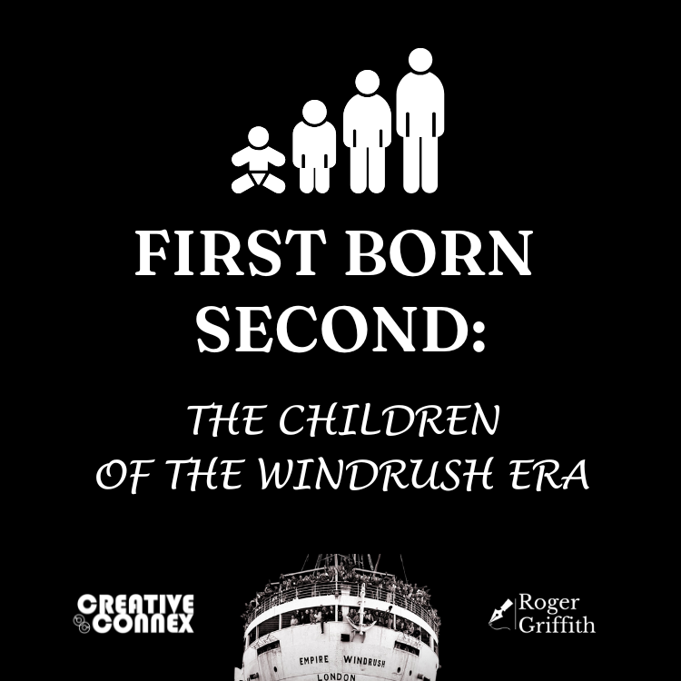
FIRST BORN SECOND: CHILDREN OF THE WINDRUSH ERA
CALL-OUT FOR WRITING & ARTISTIC WORK FOR OUR ANTHOLOGY
Submission - Top Sheet
Email this completed form and your work to firstbornsecond.cc@gmail.com with the email subject Anthology Submission - [Your Name].
Name:
Age: (if under 16)
Address:
Postcode:
Contact email:
Title of your piece:
This is a: (delete as appropriate) | poem/ flash-fiction/ essay/ memoir /artwork
Word count:
(if applicable)
About me: (50-word max minibiography)

Declaration: I hereby declare that this is an original unpublished work and that I am the author. I give First Born Second permission to publish this work on a Creative Commons (attribution/no fee) basis.
(If this is a collaborative piece, e.g. graphics/text, all contributors should make this declaration)
Digital Signature:
Name:
Date:
NB: You can copy and paste your work here and submit it as a single document. Please ensure that your name and the title of the piece are on each page of the document (s) submitted.

